Market Analysis Example for Technology Valuation

Disclaimer
This sample document has been made available by the Ministry of Science and Education of the Republic of Croatia for informational purposes only and does not constitute advertising, a solicitation, or legal advice.

The content of the documents do not espouse an official opinion on the subject matter nor definitive manner in which market analyses should be conducted.

Introductory remarks
This document provides an example of a simple market analysis that may be conducted for the purpose of technology valuation. The main objective of this analysis is to estimate the commercial value of the technology and to help objectively quantify its revenue potential. To quantify the value of the technology, it is necessary to describe the current situation in the relevant industry, describe and define potential customers and competitors. The analysis provides a high-level assessment of the technology and relevant market segments; defines an innovation’s technological framework; and reviews related patents to evaluate the technology market potential.
This is a first step analysis that technology transfer offices can prepare relatively quickly and with minimal resources. The document is intended to guide technology transfer offices and public research organizations to prepare a basic market analysis in-house before deciding whether to invest in a more detailed and comprehensive market analysis. Researchers or research organizations may make decisions based on the initial market analysis. For example, they may choose a specific commercialization model and decide how to allocate resources in ensuing steps of the commercialization process.
After a certain point, researchers and research organizations will likely need more in-depth market research and should, when possible, consult market experts in the field in question. Each technology will seek its own analysis and, where applicable, experts should be consulted. For additional guidance on commercialization and technology transfer please refer to the National Technology Transfer Guidelines and related templates.
How to use the example
The example contains tips that guide the user through the tools and processes used to prepare the market analysis. The analysis tips are denoted by a blue box, titled ANALYSIS TIPS. Additionally, the tips may reflect some considerations and alternatives that users are encouraged to take into account, relative to their specific capacities and needs.

Biodegradable polymer composition for producing packaging films
Market analysis

July 2023

Contents
Introduction - 4 -
1. Sector Structure Analysis - 4 -
a. International Trade Analysis - 5 -
b. Patent Activity Analysis - 6 -
c. Trend Analysis of Biodegradable Plastics - 11 -
2. Customer Analysis - 12 -
3. Competitor Analysis - 14 -
4. Conclusions - 16 -
Sources - 17 -

Introduction
ANALYSIS TIP
The purpose of the introduction is to provide context to the analysis. The introduction should clearly state the scope. Make sure to be as specific and concise as possible. State the relevant market segment, briefly describe the technology for which the market analysis is conducted and identify the geographic scope of the relevant market.

The assessed know how is a patented technology in the bioplastics segment. The analysis will cover a market diagnostic for “Biodegradable polymer composition, in particular for producing packaging films with increased barrier properties, and a method of producing films”, application no. CZ2020606, invested at the University of Tomáš Baťa, Zlín, Czechia. The technology was filed for patent in 2020 and granted in 2022. The biodegradable polymer composition is formed based on a polylactide matrix of which 5% to 20% is a nucleating agent which is calcium carbonate or nanocellulose. It is particularly suitable for producing packaging films with increased barrier properties for gases such as air, oxygen, nitrogen, carbon dioxide. The films can be used primarily as biodegradable packaging for perishable foodstuffs. Geographically, the relevant market is mainly Europe with a global dimension.

- Sector Structure Analysis
ANALYSIS TIP
The industry analysis is divided into three parts:
1. international trade,
2. patent activity, and
3. trend analysis of the biodegradable plastics industry.
The first part of the analysis offers a macroeconomic view of the main industry trends from an international trade perspective. This section provides the contextual framing for the other, more detailed sections.
The second part of the analysis captures the underlying trends in patent activity in a well-defined sample of patents based on similarity to the technology in question.
The third part focuses on the size and evolution of the relevant market in which the subject technology is potentially most applicable.
Combining these several views on the structure of the industry provides an insight into the relevant trends and specificities. When preparing the analysis, consider the specifics of the industry and consult field experts.
  - International Trade Analysis
ANALYSIS TIP
This section presents data and trends in international trade relevant to the technology in question. The analysis should, at a minimum, cover trends in import and export values for related commodities and geographic distribution of importers and exporters. For data on international trade, you may consult the UN Comtrade database: https://comtrade.un.org/data.
It is important to select the relevant commodities carefully; if the exact commodity group is not available, you may select a similar one as close as possible to the relevant technology. In this example, data for biodegradable plastics is not available. Since the patented technology is expected to be used in the packaging market, the analysis uses a wider market segment of plastic articles for conveyance or packing of goods.
International trade trends show a steadily growing global market for plastic articles for the conveyance or packing of goods. Specific data for biodegradable plastics trade are not available, therefore a wider market segment of plastic articles for the conveyance or packing of goods was chosen to illustrate a general overview of market development. Between 2017 and 2020, the value of international trade was relatively stable, however, in 2021 there was a significant growth in both export and import. The market value of global trade in the subject area increased from USD 52 billion in 2017 to USD 66 billion in 2021 (Figure 1).
Figure 1: International Trade in Plastic articles for the conveyance or packing of goods, 2017-2021
Source: UN Comtrade; note: HS (as reported) commodity code 3923 (Plastic articles for the conveyance or packing of goods; stoppers, lids, caps and other closures of plastics).
The market is disproportionately held by a few of the most developed economies. Most of these products are exported abroad from China (21%), the USA (9%) and Germany (9%). Along with France, Mexico, and the Netherlands, these countries hold over half of the export market. The remaining countries in the Top 20 account for between 1.5-3.5% of the total export market share. In terms of imports, the United States dominates the market with 16%. Other noteworthy importers include Germany, France, Mexico, and Canada.
Table 1: International trade by country, Plastic articles for the conveyance or packing of goods, 2021
Country | EXPORT (in USD) | Share of total exports (%) | Country | IMPORT (in USD) | Share of total imports (%)
China | 14 013 579 578 | 21.2 | USA | 9 736 185 562 | 16.0
USA | 5 933 867 407 | 9.0 | Germany | 4 359 927 552 | 7.1
Germany | 5 799 913 270 | 8.8 | France | 3 405 380 564 | 5.6
France | 2 944 635 302 | 4.5 | Mexico | 3 136 709 417 | 5.1
Mexico | 2 593 446 382 | 3.9 | Canada | 2 790 006 153 | 4.6
Netherlands | 2 573 109 930 | 3.9 | United Kingdom | 2 678 907 073 | 4.4
Canada | 2 340 069 749 | 3.5 | Netherlands | 2 574 408 595 | 4.2
Italy | 2 131 751 627 | 3.2 | Japan | 2 031 783 220 | 3.3
Rep. of Korea | 1 686 476 042 | 2.6 | Italy | 1 529 474 351 | 2.5
Spain | 1 643 105 031 | 2.5 | Spain | 1 450 552 914 | 2.4
Poland | 1 589 386 622 | 2.4 | China | 1 408 124 053 | 2.3
United Kingdom | 1 536 217 537 | 2.3 | Poland | 1 397 158 018 | 2.3
Thailand | 1 382 911 371 | 2.1 | Belgium | 1 318 053 460 | 2.2
Turkey | 1 263 749 461 | 1.9 | Rep. of Korea | 1 201 233 949 | 2.0
Malaysia | 1 123 225 587 | 1.7 | Australia | 1 183 212 443 | 1.9
India | 1 088 762 490 | 1.6 | Switzerland | 1 004 012 115 | 1.6
Austria | 1 006 977 897 | 1.5 | Thailand | 945 925 321 | 1.6
Belgium | 1 003 538 115 | 1.5 | Austria | 847 007 439 | 1.4
Switzerland | 827 098 169 | 1.3 | Czechia | 839 852 010 | 1.4
Czechia | 769 692 289 | 1.2 | Russian Federation | 753 039 004 | 1.2
Source: UN Comtrade; note: HS (as reported) commodity code 3923 (Plastic articles for the conveyance or packing of goods; stoppers, lids, caps and other closures of plastics).
  - Patent Activity Analysis
ANALYSIS TIP
This section reviews patent activity relevant to the technology in question. The review of patent activity should, at a minimum, include a trend analysis of relevant patents filed and approved, the legal status of similar patents, and the top patent holders.
Patsnap and Espacenet are a good starting point for patent analysis. Patsnap ( https://account.patsnap.com/) is a paid database that offers useful features and insights. In case users/institutions are not able to provide access, it is possible to use free databases, such as Espacenet. Espacenet is straightforward to use. First, it is important to define key words relevant to the patent or field where the assessed technology or product belong. Use Advanced search and change the search field for “text field” to “title, abstract, claims”.
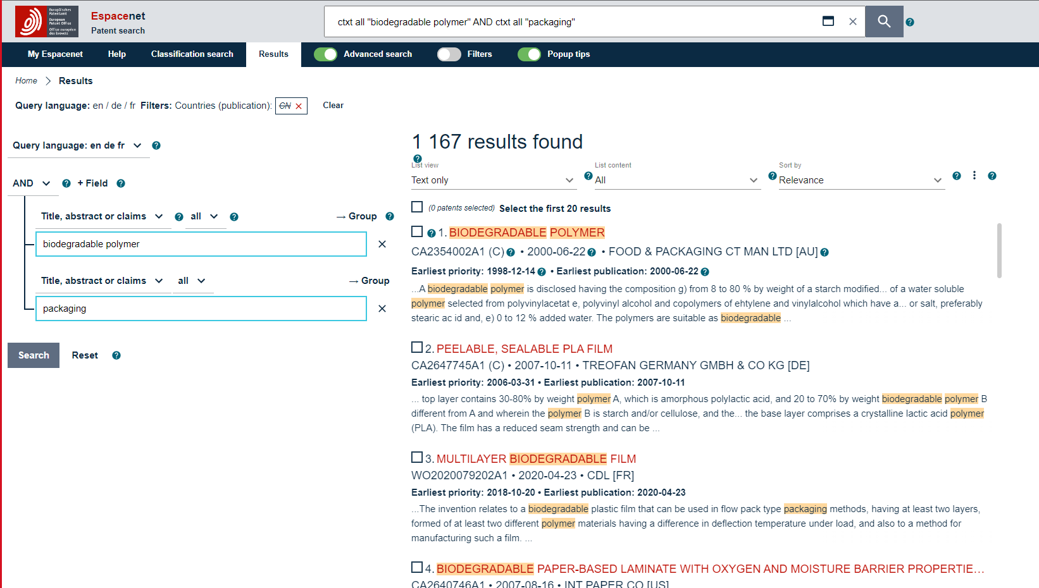
Data can be downloaded and analyzed as needed, by clicking on three dots next to the results found bar.
Espacenet also offers a concise visual overview of selected features and parameters. Select field Filters, switch them to active, and click on the “view chart/graph overview” icon.
Upon selection, the following data points and interpretations will appear: number of patents filed, top assignees, applicant country, etc.
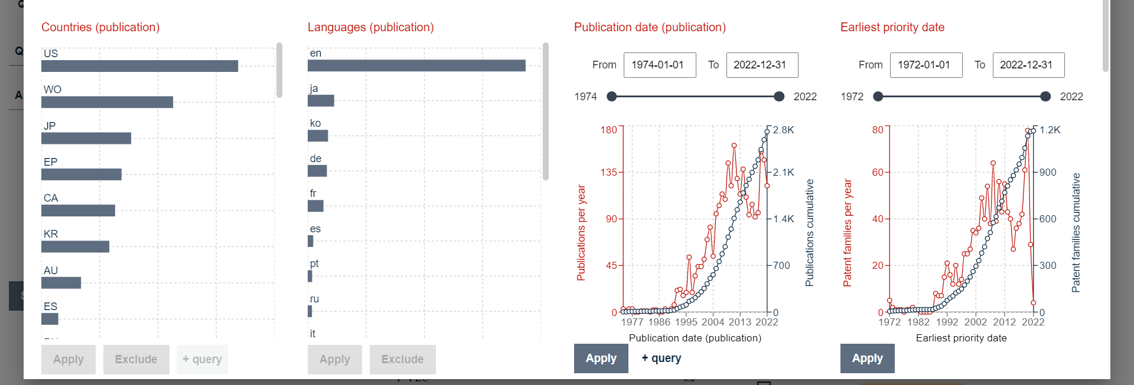
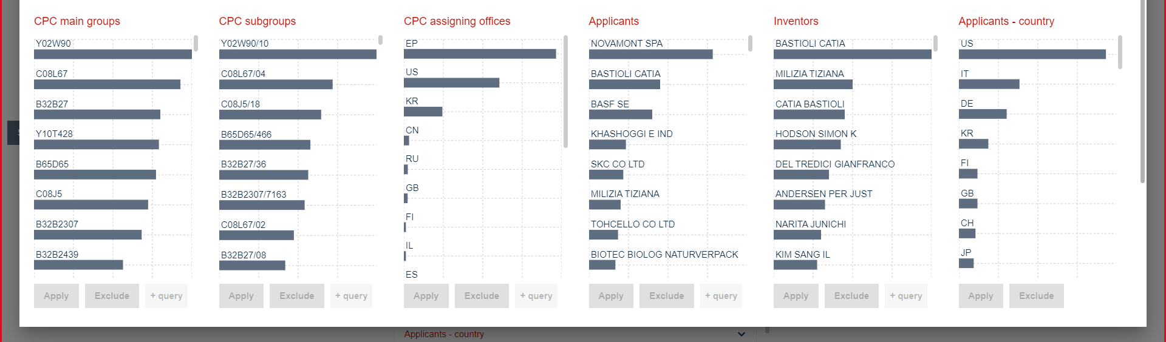
The development in patent activity shows a continuous interest in new and protected solutions in the field of biodegradable plastics. There are a total of 438 patent families that are similar in nature to the prototype in question (Patsnap). Since 2003 a total of 187 patents have been filed. Patent activity intensified in 2020, when the number of applications reached 32 patents. As shown in Figure 2, applicants have been filing around twenty applications per year in recent years. Based on the smaller number of inventions in the subject area, the rate of granted patents fluctuates. Due to the length of patent registration procedures and reporting, the figures for 2021 and 2022 may be higher than presented.
Figure 2: Evolution of the number of applications and patents granted to similar technologies in relation to the subject technology
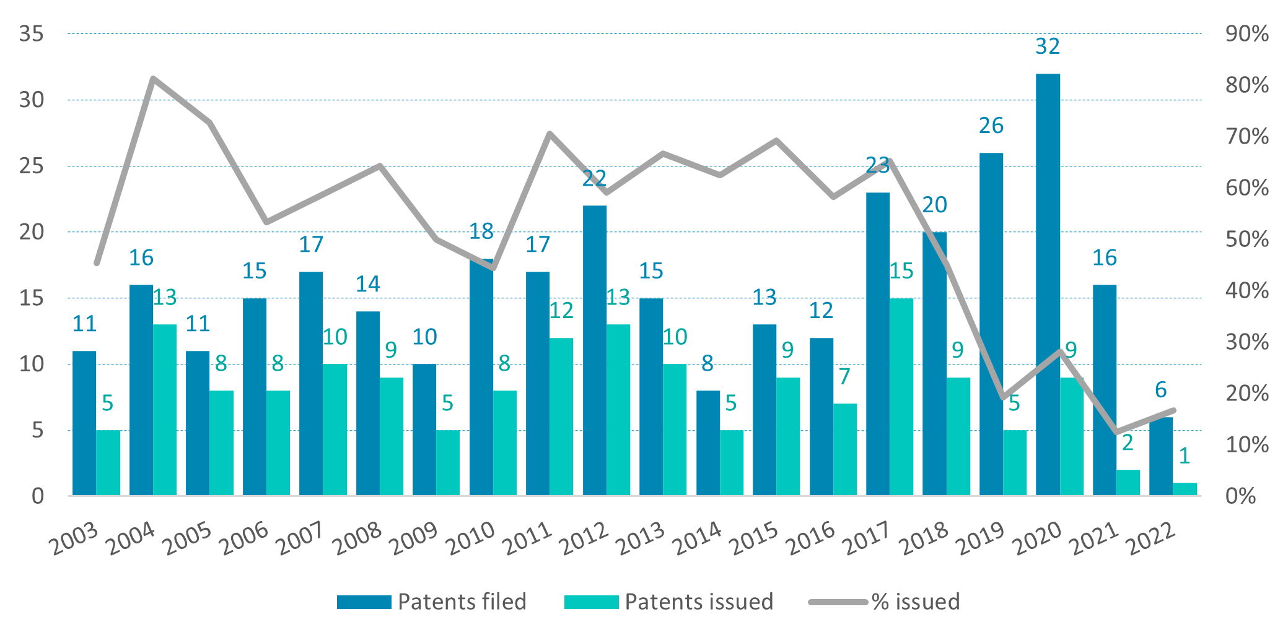
Source: Patsnap; Note: selection based on semantic search of patents like the patented technology, CZ309087B6, in 158 databases; patents by first application date; data for 2021 and 2022 are not available due to the nature of the of the patenting proceedings.
Despite the increase in patent activity in recent years, older and unprotected patents still account for a relatively high share. According to legal status data, less than one third of patents are granted, as illustrated in Figure 3. The fact that the number of granted and pending patents is smaller relative to the number of invalid (terminated or not granted) patents and the information found in Figure 2 suggest that the technology area in question has a relatively high degree of specialization with a limited number of firms and institutions.
Figure 3: Legal status of similar patents to the subject technology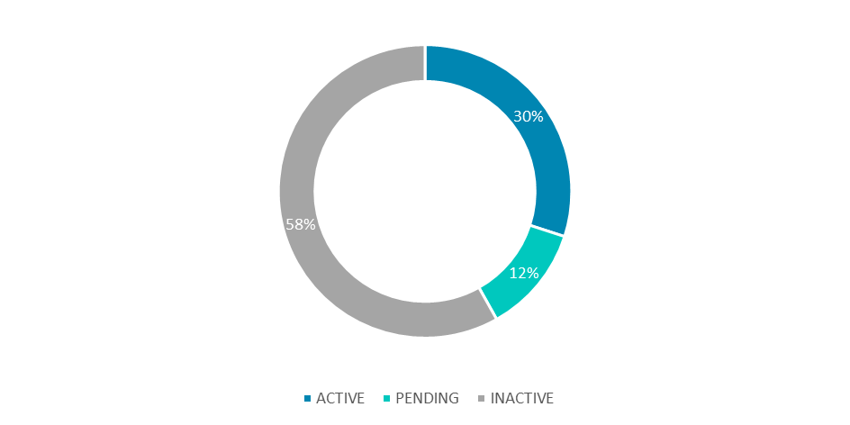
Source: Patsnap.
The patent market in the subject area is relatively narrow with a limited number of players. The top companies with the largest patent portfolios in the technology field are presented in Figure 4. The geographic distribution of patent filing in this area is shared equally by European and American companies, seconded by two Japanese entities. At the same time, only some of the leaders (in terms of patents) are maintaining or filing new patents. This is the case of the Italian company Novamont Spa, which for years has maintained first place in both the number of patents filed and the number of active patents. Gaia Holding from Sweden is a new entrant to follow given its number of applications in the field. German BASF and the US Dow Global Technologies LLC also maintain their presence and continue to submit new patent applications. Some companies were active in patenting in the past, but their patents from the 1990s and 2000s are no longer valid; these include DuPont de Nemours, Inc or Kureha Corporation. However, less than 20% of active patents belong to the largest patent holders, suggesting that there could be an opportunity for new entrants to compete.
Figure 4: Top Assignees of similar patents to the subject technology
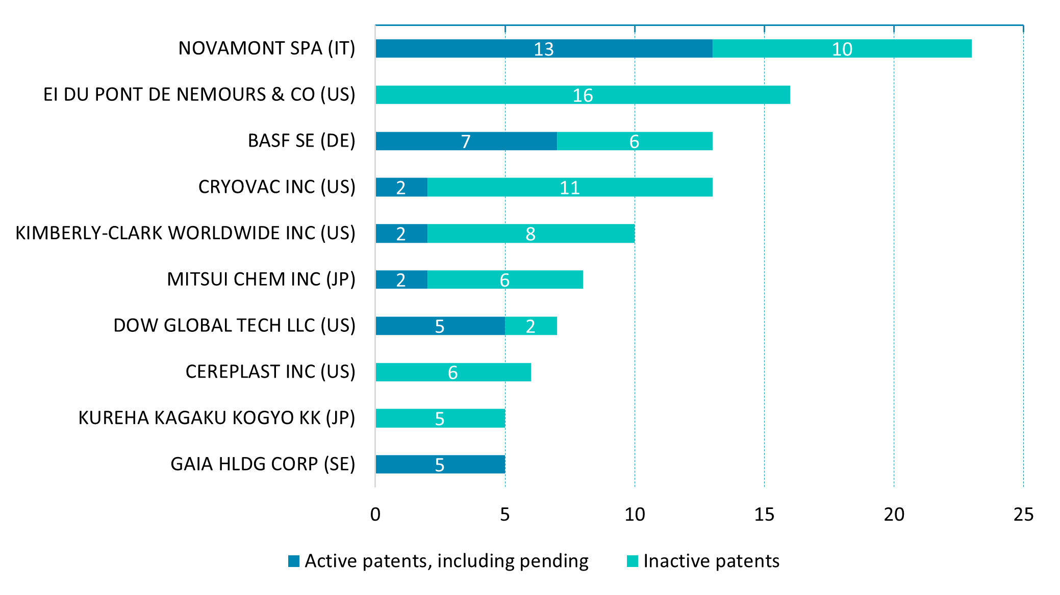
Source: Patsnap.
A similarity search was conducted to identify specific niches. Table 2 outlines key technology areas by patent and helps to understand the focus of the claimed inventions in the subject area. ‘Manufacture of articles or shaped materials containing macromolecular substances’ and ‘Compositions of polyesters obtained by reactions forming a carboxylic ester link in the main chain’ are the most frequent protected solutions in the similarity search.
Table 2: Key technology areas by patent frequency
Classification IPC | Definition | No. of patents | Percentage
C08J5 | Manufacture of articles or shaped materials containing macromolecular substances (manufacture of semi-permeable membranes B01D 67/00-B01D 71/00) | 246 | 20.3 %
C08L67 | Compositions of polyesters obtained by reactions forming a carboxylic ester link in the main chain (of polyester-amides C08L 77/12; of polyester-imides C08L 79/08); Compositions of derivatives of such polymers | 241 | 19.9 %
B65D65 | Wrappers or flexible covers; Packaging materials of special type or form (wrappers or envelopes with shock-absorbing properties B65D 81/03) | 149 | 12.3 %
B32B27 | Layered products essentially comprising synthetic resin | 106 | 8.8 %
C08K5 | Use of organic ingredients | 102 | 8.4 %
C08K3 | Use of inorganic substances as compounding ingredients | 100 | 8.3 %
C08L101 | Compositions of unspecified macromolecular compounds | 76 | 6.3 %
C08L23 | Compositions of homopolymers or copolymers of unsaturated aliphatic hydrocarbons having only one carbon-to-carbon double bond; Compositions of derivatives of such polymers | 70 | 5.8 %
C08L3 | Compositions of starch, amylose, or amylopectin or of their derivatives or degradation products | 67 | 5.5 %
C08L1 | Compositions of cellulose, modified cellulose, or cellulose derivatives | 54 | 4.5 %
Source: Patsnap.

  - Trend Analysis of Biodegradable Plastics
ANALYSIS TIP
This section contains estimates of market size, actors, and activities. Market segmentation is key in revealing the patent’s potential value.
Market reports for specific markets can be found online, using search engines. However, most market agencies provide samples or brief summaries of their reports for free; full versions are usually available for purchase. It is useful to compare a few reports as their data can differ, probably depending on the used methodology. It is also important to pay particular attention to the most recent estimates.
The biodegradable plastics market shows resilient growth forecasts. According to available estimates, the biodegradable plastics market is currently worth between USD 1.6 and 7.7 billion. The market is estimated to grow at 9.5% to 24.9% per annum over the next few years, according to various sources (Table 3).
The global bioplastics market is stimulated by several drivers. These include growing end-user demand and acceptance, rising environment and sustainability awareness, and more stringent regulation and development of low-cost bioplastics (e.g., sugar cane, fruit skin). In comparison to conventional polymers/petroleum-based articles, degradable bioplastics incur higher production and development costs. Given their small-scale production their prices often vary, but more likely than not remain uncompetitive (price-wise) with conventional plastics.
Biodegradable plastics are most represented in packaging, consumer goods, textiles, and agriculture, with Europe being potentially the largest market. In 2020, packaging was estimated to account for almost 47% of the total biodegradable plastics market. In line with the findings of the patent analysis, Europe is expected to hold largest market share of degradable bioplastics. This is largely due to the deepening of regulatory requirements and the implementation of sustainable strategies, both at supranational, national, and firm level.
Table 3: Comparison of global market growth forecasts
Research Agency | Market Size | Compound annual growth rate (CAGR) | Period
Markets and Markets | USD 7.7 billion (2021) | 24.9% | 2021-2026
Allied Market Research | USD 1.6 billion (2019) | 13.3% | 2020-2027
Spherical Insights | USD 7.7 billion (2021) | 16.4% | 2021-2030
Research Dive | USD 4.3 billion (2021) | 9.5% | 2021-2028
Source: Research agency reports.
- Customer Analysis
ANALYSIS TIP
This section identifies potential customers for the technology in question. It should include a list of potential fitting customers. Customers can be identified from market reports used in previous sections. Detailed information about the companies can be found online, both on their organization website and in press reports.

The analysis suggests that the patented technology can be sold within the supply chain, particularly via the business-to-business (B2B) route. In this case, a typical customer would be a biodegradable plastics producer. A company with in-house research and development should be considered an advantage. Such a partner is more likely to be able to prepare the technology for the specific market segment (food packaging companies) and will have supply chains already in place to bring the product to market.
Most potential customers are from Europe and the United States. Table 4 provides an overview of the most important companies in the market that are involved in the production of biodegradable plastics. It is evident that both European and American entities dominate the market. Some companies diversify their portfolios, e.g., Carghill, a privately owned global corporation invested in a few companies, including NatureWorks (US) and Croda International (UK). Some focus on the whole lifecycle of bioplastics (Futerro), while others offer their customers tailored approaches to develop their products from their materials (FKUR).
Table 4: Biodegradable Plastics Leaders
Company Name | Country | Web | Detail
BASF SE | Germany | http://basf.com/ | German multinational chemical company and the largest chemical producer in the world. Seven business segments, bioplastics within the plastics segment. BASF developed a biodegradable plastic with a high content of polylactic acid.
Biome Technologies plc, | United Kingdom | https://biometechnologiesplc.com/ | Biome Bioplastics produces a range of high-performance, plant-based bioplastics that are biodegradable and compostable. Also leading a £5 million R&D program with academic and industrial partners aimed at reinventing the intrinsic synthesis of bioplastics to both improve performance and reduce cost.
Cargill Incorporated | USA | http://www.cargill.com/ | A privately held American global food corporation based in Minnesota. Major businesses are among others trading, purchasing, and distributing grain and other agricultural commodities, and producing food ingredients such as starch and glucose syrup, vegetable oils and fats for application in processed foods and industrial use.
Danimer Scientific | USA | https://danimerscientific.com/ | Producing natural biopolymers that are biodegradable and compostable. Owns 125 patents in nearly 20 countries. E.g., bioplastic called PHA using microorganisms that ferment with canola oil.
Eastman Chemical Company | USA | https://www.eastman.com/en | Specialty materials production: a broad range of advanced materials, chemicals, and fibers for everyday purposes
FKuR Kunststoff GmbH | Germany | https://fkur.com/ | Portfolio of bioplastics for the circular economy, recycles and bio-recycle hybrids for all processing methods.
Futerro | Belgium | https://www.futerro.com/ | Pioneer of development of lactic acid and Poly-Lactic Acid (PLA). Extensive industrial experience in lactic acid and PLA production on different substrates. Their services include recycling technology LOOPLA®.
NatureWorks LLC | USA | https://www.natureworksllc.com/ | A joint venture by Cargill, one of the world's largest privately held corporations, and Thailand-based PTT Global Chemical. Manufactures Ingeo brand polylactic acid (PLA) and lactides, usually produced by fermenting sugar from corn and sugar cane.
Novamont SpA | Italy | https://www.novamont.com/eng/ | International leader in the bioplastics sector and in the development of biochemicals. Four production sites, four research centers.
Plantic Technologies Limited | Australia | https://plantic.com.au/ | World leading innovator in bioplastics. PLANTIC™ starch technology. Subsidiaries in UK and Germany.
PTT MCC Biochem Co., Ltd. | Thailand | https://www.pttmcc.com/what-is-biopbs | Strategic joint venture company between PTT Global Chemical Public Company Limited (GC) and Mitsubishi Chemical Corporation (MCC). Produce BioPBS, partially Bio-based Polybutylene Succinate
Synbra Technology BV | Netherlands | http://www.synbratechnology.nl/ | Manufacture of Styrex® Expandable Polystyrene (EPS) beads, BioFoam® Expandable Polylactic acid (PLA) and PS and PLA Compounds. The largest EPS recycler in Western Europe.
Total Corbion PLA | Netherlands | https://www.totalenergies-corbion.com/ | Focus on Poly Lactic Acid (PLA) and lactide monomers. Developed a high heat resistant solution for PLA-based bioplastics.
Trineso | USA | https://www.trinseo.com/Products/Plastics/Products/Bioplastics | Flagship STYRON™ Polystyrene, MAGNUM™ ABS, and TYRIL™ SAN resins with renewable content.
Source: Companies identified from market analyses, detailed info about the companies compiled by desk research.

- Competitor Analysis
ANALYSIS TIP
This section identifies competitors for the technology in question. For the competitor analysis, you may select entities using two approaches. First, identify the most valuable patent holders for the technology. Second, identify companies that own the most similar solutions based on semantic similarity to the subject technology.
Competitors can be identified using Patsnap features such as the most valuable and most similar patents to the assessed technology/product. Patsnap estimates the market value of a patent based on available data using over 80 indicators that are relevant for market value. These include citation performance, patent family size, geographic coverage, patent age, legal status of the patent, as well as indicators calculated from historical patent transaction data. When using Patsnap, click on the patent number to learn about the patented technology in more detail, including patent claims. Espacenet does not offer the same level of detail, however it is possible to identify top patent assignees, as described in section 1.a.

European companies own the most valuable in-group technologies, while the most similar technologies are patented elsewhere globally. Besides two non-European patents—USA and Israel—the most valued patented technologies are held by European companies from Italy, Germany, and Finland.
Table 5 Highest market-valued patents in the subject technology field
Publication Number | Application Year | Title | Current Assignee | Current Assignee Country | Patent Valuation (USD)
EP1697462B1 | 2004 | Polymer blends with improved rheology and improved unnotched impact strength | NOVAMONT SPA | IT | 6,190,000
US9181010B2 | 2011 | Heat-sealable biodegradable packaging material, a method for its manufacture, and a product package made from the material | STORA ENSO OYJ | FI | 5,130,000
US7368503B2 | 2004 | Compatibilized blends of biodegradable polymers with improved rheology | NOVAMONT SPA | IT | 5,120,000
US20140110301A1 | 2013 | Pvp copolymer for harsh chemical packaging | SEKISUI SPECIALTY CHEMICALS AMERICA, LLC. | US | 4,550,000
US9228066B2 | 2008 | Polymer material and method for the production thereof | BIOTEC BIOLOGISCHE NATURVERPACKUNGEN GMBH & CO. KG | DE | 4,480,000
US10501607B2 | 2018 | Polyphase biodegradable compositions containing at least one polymer of vegetable origin | NOVAMONT S.P.A. | IT | 4,310,000
US9878839B2 | 2013 | Seaweed-based food packaging coating | MANTROSE-HAEUSER COMPANY, INC. | US | 4,190,000
US10526461B2 | 2013 | Biodegradable polyester mixture | BASF SE | DE | 4,050,000
US11007758B2 | 2020 | Biodegradable sheet | TIPA CORP. LTD | IL | 3,990,000
US11345779B2 | 2019 | Aliphatic-aromatic biodegradable polyester | NOVAMONT S.P.A. | IT | 3,980,000
Source: Patsnap.
Table 6: The most similar patents in the subject technology field
Publication Number | Application Year | Title | Current Assignee | Current Assignee Country | Patent Valuation
US7854994B2 | 2005 | Barrier film | PLANTIC TECH | AU | 2,990,000
US8410200B2 | 2007 | Polymeric films | PLANTIC TECH | AU | 1,480,000
EP1297949B1 | 2002 | A biaxially stretched biodegradable polyester film and a laminated film | TOHCELLO CO LTD | JP | N/A
US20090324917A1 | 2008 | Biodegradable Packaging Film | KIMBERLY-CLARK WORLDWIDE INC | US | N/A
US20110135912A1 | 2010 | Biodegradable packaging materials with enhanced oxygen barrier performance | THE MEAD CORP | US | N/A
US8852747B2 | 2008 | Coextrusion binders on a renewable/biodegradable basis | SK GEO CENTRIC CO LTD | KR | 1,850,000
US7707803B2 | 2009 | Biodegradable bags for packing foods available in high-speed production | ISHIDA CO LTD | JP | N/A
US20110046281A1 | 2009 | Polymer compositions having poly(lactic acid) | CEREPLAST INC | US | N/A
US20110126497A1 | 2007 | Method to produce a biodegradable plastic film, and film | INFIANA GERMANY GMBH & CO KG | DE | N/A
WO2022101321A1 | 2021 | Polyester-based composition with high barrier properties and articles of packaging containing the same | POINT PLASTIC SRL | IT | N/A
Source: Patsnap.
- Conclusions

ANALYSIS TIP
This section provides a summary of the analysis presented in the previous sections. The purpose of this section is to conclude whether the technology in question has any commercialization potential and what are the factors that will affect the market potential of the technology in the future.

The initial market analysis of the biodegradable plastics industry reveals a promising commercialization potential of the technology in question. Driven by increasing environmental concerns and regulatory measures aimed at reducing plastic waste the demand for sustainable alternatives to traditional plastics has paved the way for the rapid growth and adoption of biodegradable plastics. The market for biodegradable plastics has experienced substantial growth over the past decade and is projected to continue on an upward trajectory. Secondly, noteworthy patents exist, but many are older and are often unprotected. Existing patent valuation is high and concentrated in a few key actors, largely from developed countries as well as China.
The technology’s market potential will be affected by improvements in performance, cost-effectiveness, and scalability of biodegradable plastics. Technological advancements to develop innovative manufacturing processes and the exploration of novel materials will play a pivotal role in shaping the future of this industry. As consumers become more environmentally conscious and regulations become stricter, the biodegradable plastics market is poised to become a vital component of the global transition towards a more sustainable future.

Sources

ANALYSIS TIP
In this section, list all the sources used to conduct the analysis.

Databases
Espacenet, 2022. [online]. Available: https://worldwide.espacenet.com/

Patsnap, 2022. [online]. Available: https://www.patsnap.com/

UN Comtrade, 2022. International Trade Statistics [online]. Available: https://comtrade.un.org/Data/.

Volza, 2022. Global Trade Data [online]. Available: https://www.volza.com/p/biodegradable-plastic/

Primary Research
Allied Market Research (2020): Biodegradable Plastics Market by Biodegradable Plastic Type and Biodegradable Plastic Application: Opportunity Analysis and Industry Forecast. [online, 2022-10-31] Available: https://www.alliedmarketresearch.com/biodegradable-plastic-market

Markets and Markets (2021): Biodegradable Plastics Market by Type (PLA, Starch Blends, PHA, Biodegradable Polyesters), End Use Industry (Packaging, Consumer Goods, Textile, Agriculture & Horticulture], and Region (APAC, Europe, North America & Rest of World). [online, 2022-10-31] Available: https://www.marketsandmarkets.com/Market-Reports/biodegradable-plastics-93.html

Spherical Insights (2022): Global Biodegradable Plastics Market Size, Share and COVID-19 Impact Analysis – Global Insights, Growth, Size, Comparative Analysis, Trends and Forecast, 2021-2030. [online, 2022-11-1] Available: https://www.sphericalinsights.com/reports/biodegradable-plastics-market

Research Dive (2021): Biodegradable Plastics Market by Material Type, Application and Regional Analysis: Global Opportunity Analysis and Industry Forecast, 2021-2028. [online, 2022-11-1] Available: https://www.researchdive.com/7383/biodegradable-plastics-market

European Bioplastics (2021): Bioplastics Market Development Update 2021. [online, 2022-11-1] Available: https://docs.european-bioplastics.org/publications/market_data/Report_Bioplastics_Market_Data_2021_short_version.pdf
Expert Literature
Moshood, Taofeeq D., Nawanir, Gusman, Mahmud, Fatimah, Mohamad, Fazeeda, Mohd Hanafiah Ahmad, Abdul Ghani, Airin (2021): Expanding Policy for Biodegradable Plastic Products and Market Dynamics of Bio-Based Plastics: Challenges and Opportunities; Sustainability 2021, 13(11), 6170: https://doi.org/10.3390/su13116170

Moshood, Taofeeq D., Nawanir, Gusman, Mahmud, Fatimah, Mohamad, Fazeeda, Mohd Hanafiah Ahmad, Abdul Ghani, Airin (2022): Biodegradable plastic applications towards sustainability: A recent innovations in the green product; Cleaner Engineering and Technology, Volume 6, 2022, 100404, ISSN 2666-7908, https://doi.org/10.1016/j.clet.2022.100404

Döhler, Niklas, Wellenreuther, Claudia, Wolf, André: Market dynamics of biodegradable bio-based plastics: Projections and linkages to European policies, EFB Bioeconomy Journal, Volume 2, 2022, 100028, ISSN 2667-0410, ; https://doi.org/10.1016/j.bioeco.2022.100028

Kristiina Kerge (2020): What are biodegradable plastics? The Need for Clarified Terminology; Let’s do it Foundation blog, [online 2022-11-1], available: https://letsdoitfoundation.org/2020/09/04/what-are-biodegradable-plastics-the-need-for-a-clarified-terminology/

European Bioplastics. Market update 2020. https://www.european-bioplastics.org/market/
A detailed overview of members of the European Bioplastics Association (EUBP) is available here: https://docs.european-bioplastics.org/association/EUBP_members_list.pdf.

